Documentation for Exporting GitLab Cloud to Self-Hosted Server.

Step 1: Open a GitLab Cloud Instance and click the Project that we want to be export.

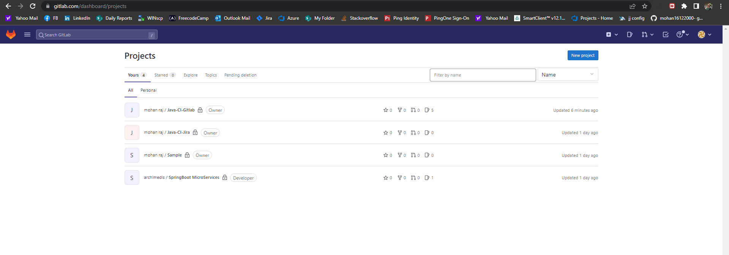

Step 2: Click the Setting -> General on the Bottom Left.

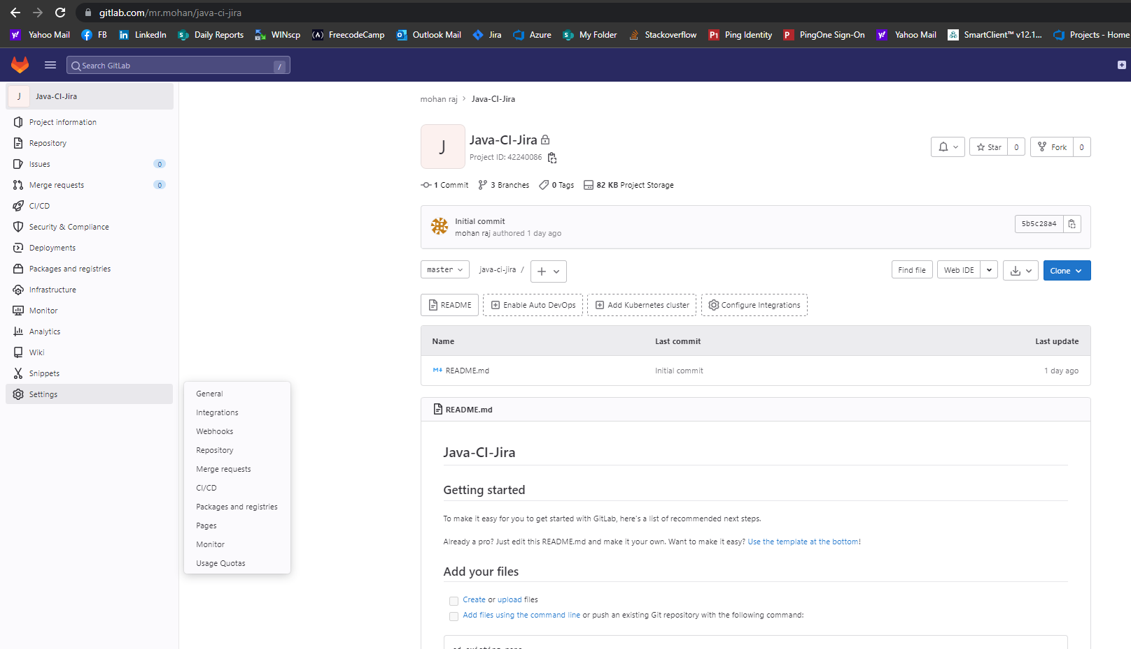

Step 3: Click the expand option on Advanced at bottom of the page.

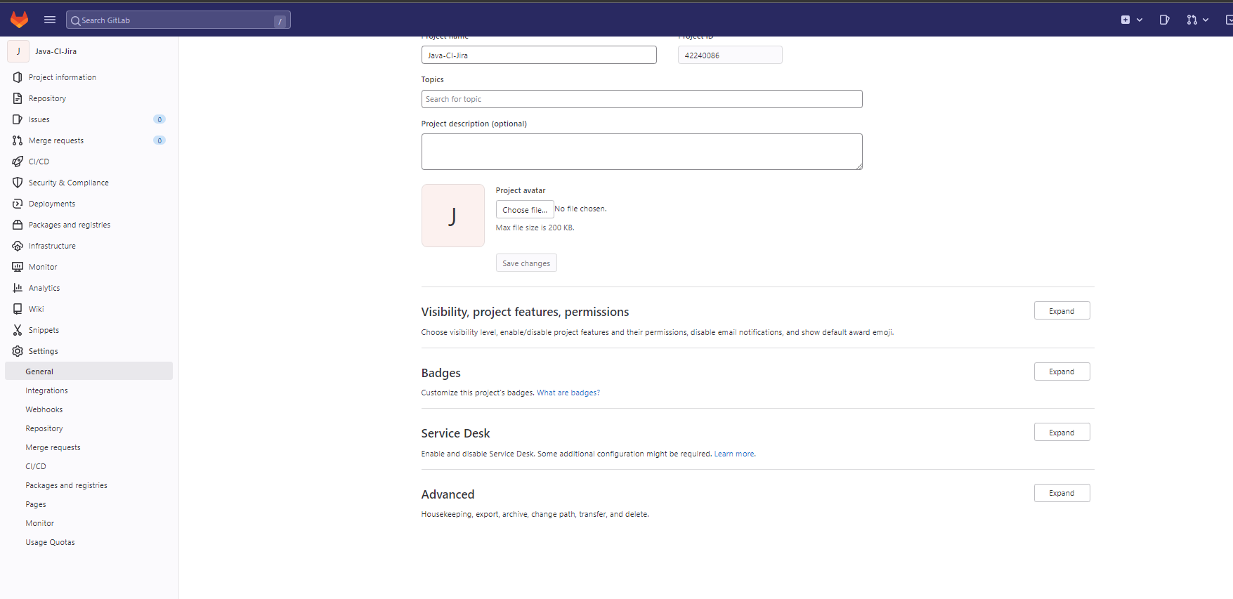

Step 4: On Export Project click the generate new export option first.

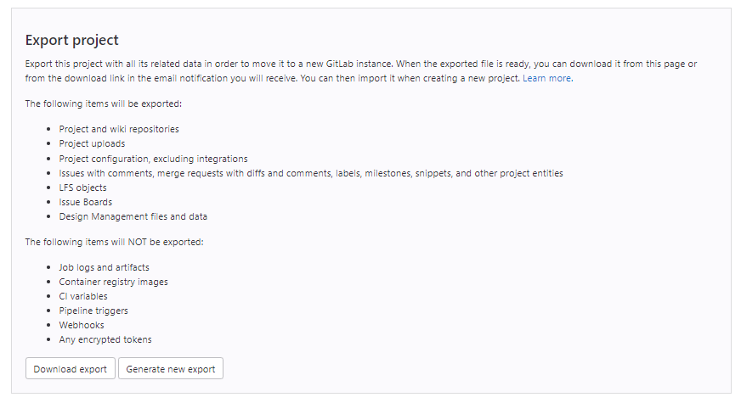

Step 5: you got the message on the top.

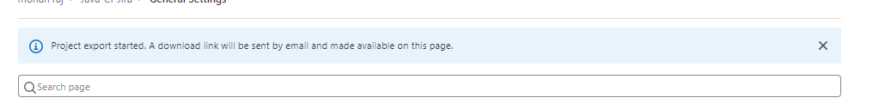

Step 6: Click Download Export as a figure shown on Step 4.

Step 7: Open the self-hosted GitLab Server.

Step 8: Click on the new project option on top right.

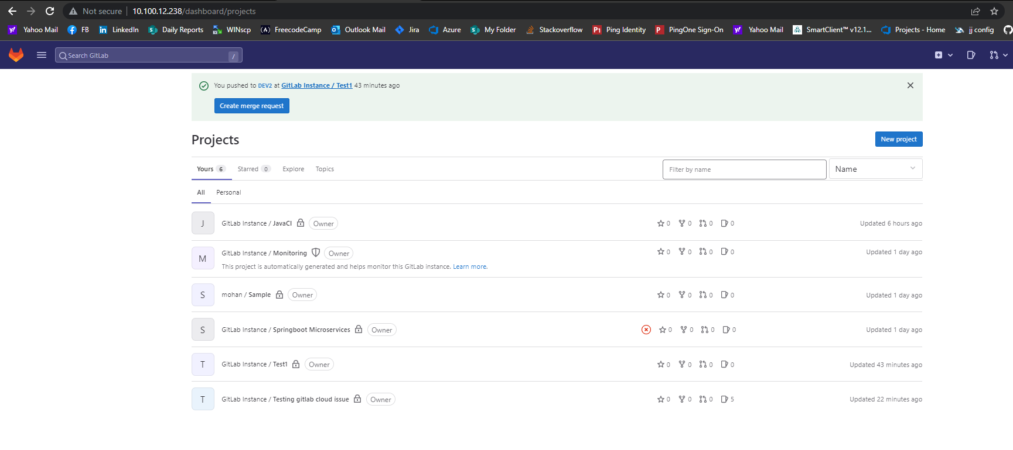

Step 9: Click on the import project option.

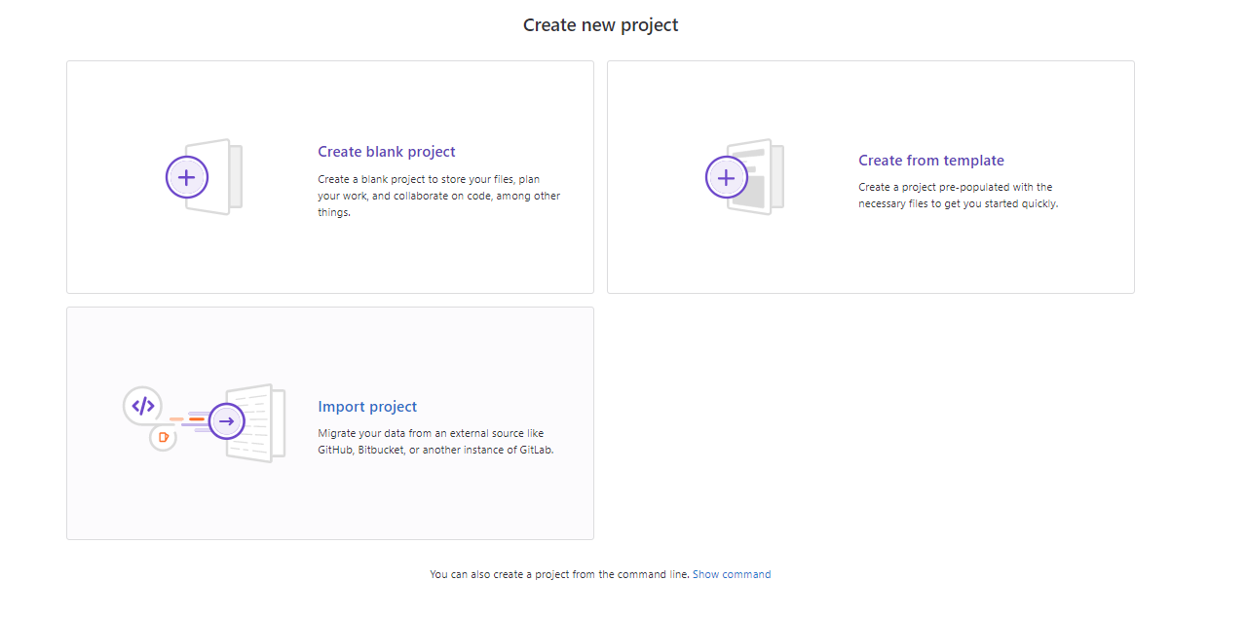

Step 10: Select the GitLab export as Import project from.

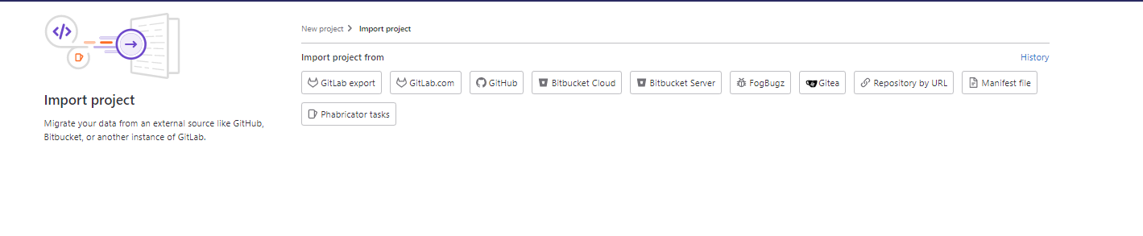

Step 11: Enter the project name and Choose the file that we are exported from GitLab Cloud and click import project.

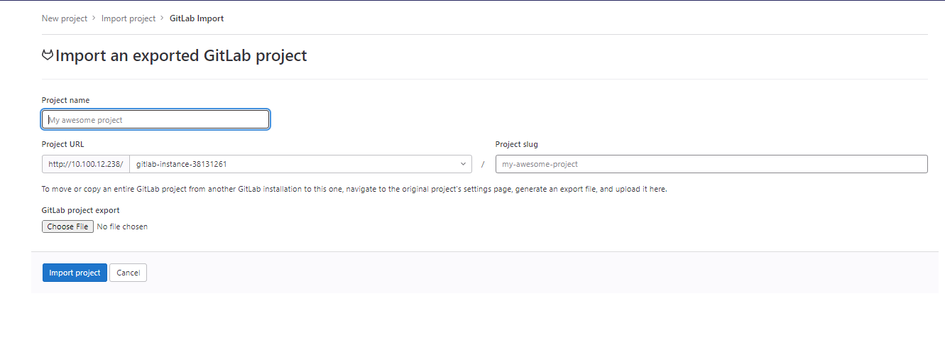

Step 12: After Click the option the project is getting import.

